Table of contents
108 names of Bhagwan Sathya Sai Baba (Shri Sathya Sai Ashtottram)
1. | GuruVandana
2. | Aumkaram
3. | Ganesh Mantra
4. | Gurur Brahma
5. | Morning prayer – Lakshmi, Saraswati and Gauri
6. | Vishnu Stotra
7. | Saraswati Stotra
8. | Devi Mantra
9. | Shanti Mantra - I
10. | Shanti Mantra – II
11. | Shanti Mantra – III
12. | Shanti Mantra IV - Universal prayer
13. | Sloka on God – Twameva mata..
14. | Night prayers for forgiveness
15.  16.  17. | Ganaanaa Naam Tva  The Lord’s prayer  Lord Budha’s prayer
18.  19. | Gayatri Mantras  Morning prayer and evening prayer
20. | Prayer before meals
21. | Sarva Dharma
22. | Arathi (in praise of the Lord)
23  24.  25.  26.  . | Vibhuthi  Five human values  Nine points of conduct  Ten-fold path to Divinity.  Acknowledgement: some of the slokas and prayers are from the following Web sites:  http://www.sathyasai.org/devotion/prayers/gayatri.html (page for prayers)  http://www.greenmesg.org/mantras_slokas/sri_shiva-omkaram_bindu_samyuktam.php  http://saiprema.files.wordpress.com/2011/12/bhajanbook.pdf  http://www.sathyasai.org/devotion/tenPrinciples.html  Sri Sathya Sai Ashtottaram  1. Om Sri Bhagawan Sathya Sai Babaya Namaha I worship Lord Sai who is our eteranal Divine Mother and Father  2. Om Sri Sai Sathya Swarupaya Namaha I worship Lord Sai who is the embodiment of Truth and Righteousness  3. Om Sri Sai Sathya Dharma Paraayanaaya Namaha I worship Lord Sai who is Devoted to Truth and Righteousness  4. Om Sri Sai Varadaaya Namaha I worship Lord Sai who is Giver of Boons  5. Om Sri Sai Sat Purushaaya Namaha I worship Lord Sai who is eternal existing Truth  6. Om Sri Sai Sathya Gunaatmane Namaha I worship Lord Sai who is the embodiment of virtues  7. Om Sri Sai Sadhu Vardhanaaya Namaha I worship Lord Sai who spreads goodness all around  8. Om Sri Sai Sadhu Jana Poshanaaya Namaha I worship Lord Sai who enriches and sustains the virtuous  9. Om Sri Sai Sarva Jnaaya Namaha I worship Lord Sai who is omniscient  10. Om Sri Sai Sarva Jana Priyaaya Namaha I worship Lord Sai who is dear to all  11. Om Sri Sai Sarva Shakti Murtaye Namaha I worship Lord Sai who is the embodiment of all powers  12. Om Sri Sai Sarveshaaya Namaha I worship Lord Sai who is Supreme  13. Om Sri Sai Sarva Sanga Parithyaagine Namaha I worship Lord Sai who is One without any attachment  14. Om Sri Sai Sarva Antharyaaminey Namaha I worship Lord Sai who is the inner motivator of all  15. Om Sri Sai Mahimaatmane Namaha I worship Lord Sai who is Supreme Glory  16. Om Sri Sai Maheshwara Swarupaaya Namaha I worship Lord Sai who is the embodiment of Lord Shiva  17. Om Sri Sai Parthi Graamodbhavaaya Namaha I worship Lord Sai who incarnates in Parthi village  18. Om Sri Sai Parthi Kshetra Nivaasine Namaha I worship Lord Sai who is Resident of Parthi  19. Om Sri Sai Yashakaya Shirdi Vaasine Namaha I worship Lord Sai who was is the previous incarnation of Shirdi  20. Om Sri Sai Jodi Aadi Palli Somappaaya Namaha I worship Lord Sai who assumed the form of Lord ‘somappaya’  21. Om Sri Sai Bhardwaj Rishi Gothraaya Namaha I worship Lord Sai who is descendant of Sage Bhaaradwaja  22. Om Sri Sai Bhakta Vatsalaaya Namaha I worship Lord Sai who is affectionate towards devotees  23. Om Sri Sai Apantaratmaney Namaha I worship Lord Sai who is beyond the cycle of birth  24. Om Sri Sai Avataara Murtaye Namaha I worship Lord Sai who is embodiment of Incarnation  25. Om Sri Sai Sarva Bhaya Nivaarine Namaha I worship Lord Sai who removes all fears  26. Om Sri Sai Apastaambha Sutraaya Namaha I worship Lord Sai who is born in Sage Apastambha lineage  27. Om Sri Sai Abhaya Pradaaya Namaha I worship Lord Sai who grants fearlessness  28. Om Sri Sai Ratnaakara Vamshodbhavaaya Namaha I worship Lord Sai who is born in Ratnakar dynasty  29. Om Sri Sai Shirdi Abheda Shakti Avaavataaraya Namaha I worship Lord Sai whose Glory is Lord Shirdi Sai reincarnated  30. Om Sri Sai Shankaraaya Namaha I worship Lord Sai who is Lord Shiva  31. Om Sri Sai Shirdi Sai Moortaye Namaha I worship Lord Sai who is Incarnation of Shirdi Sai  32. Om Sri Sai Dwaarakamayi Vaasine Namaha I worship Lord Sai who is resident of Dwaarakamayi temple in Shirdi  33. Om Sri Sai Chitravathi Tata Puttaparthi Vihaarine Namaha I worship Lord Sai who moves about on the bank of the Chitravathi river in Puttaparthi  34. Om Sri Sai Shakti Pradaaya Namaha I worship Lord Sai who bestows strength and vigor  35. Om Sri Sai Sharanaagata Tranaya Namaha I worship Lord Sai who saves those who surrender  36. Om Sri Sai Anandaaya Namaha I worship Lord Sai who is divine bliss  37. Om Sri Sai Ananda Daaya Namaha I worship Lord Sai who bestows divine bliss  38. Om Sri Sai Aartha Traana Parayanaaya Namaha I worship Lord Sai who is forever engaged in rescuing the distressed ones  39. Om Sri Sai Anaatha Naathaya Namaha I worship Lord Sai who saves those who are destitutes  40. Om Sri Sai Asahaaya Sahaayaaya Namaha I worship Lord Sai who is Saviour of the helpless  41. Om Sri Sai Loka Baandhavaaya Namaha I worship Lord Sai Who is kith and kin to all  42. Om Sri Sai Lokarakshaa Paraayanaaya Namaha I worship Lord Sai who is the protector of the world  43. Om Sri Sai Loka Naathaya Namaha I worship Lord Sai who is Lord of all  44. Om Sri Sai Deenjana Poshanaaya Namaha I worship Lord Sai who sustains the afflicted  45. Om Sri Sai Murti Traya Swarupaaya Namaha I worship Lord Sai who is Trinity: Brahama; Vishnu and Shiva  46. Om Sri Sai Mukti Pradaaya Namaha I worship Lord Sai who grants liberation  47. Om Sri Sai Kalusha Viduraaya Namaha I worship Lord Sai who removes defects and faults  48. Om Sri Sai Karuna Karaaya Namaha I worship Lord Sai who is compassionate  49. Om Sri Sai Sarva Adhaaraya Namaha I worship Lord Sai who is the Support of all  50. Om Sri Sai Sarva Hruda Vasine Namaha I worship Lord Sai who is indweller of everyone’s heart  51. Om Sri Sai Punya Phala Pradaaya Namaha I worship Lord Sai who is Giver of fruits of meritorious acts  52. Om Sri Sai Sarva Papa Kshaya Karaaya Namaha I worship Lord Sai who is remover of all sins  53. Om Sri Sai Sarva Roga Nivarine Namaha I worship Lord Sai who is the remover of all diseases – destroyer of the cycle of birth and death  54. Om Sri Sai Sarva Badha Haraaya Namaha I worship Lord Sai who is destroyer of all sufferings  55. Om Sri Sai Anant Nuta Karthine Namaha I worship Lord Sai who is the creator and who is the numerous ways of worship  56. Om Sri Sai Adi Purushaaya Namaha I worship Lord Sai who is has no beginning and no end.  57. Om Sri Sai Adi Sakthye Namaha I worship Lord Sai who is infinite power  58. Om Sri Sai Aparoopa Shaktine Namaha I worship Lord Sai who has delightful and wonderful powers  59. Om Sri Sai Avyaktha Roopine Namaha I worship Lord Sai Who is formless  60. Om Sri Sai Kam Krodha Dhwamsine Namaha I worship Lord Sai who destroys desire and anger  61. Om Sri Sai Kanak Ambara Dharine Namaha I worship Lord Sai who wears golden coloured dress  62. Om Sri Sai Adbhuta Charyaaya Namaha I worship Lord Sai who is miraculous  63. Om Sri Sai Aapad Baandhavaaya Namaha I worship Lord Sai who is the kinsmen of those in danger  64. Om Sri Sai Premaatmane Namaha I worship Lord Sai who is the form of selfless love  65. Om Sri Sai Prema Moortaye Namaha I worship Lord Sai who is embodiment of Love  66. Om Sri Sai Prema Pradaaya Namaha I worship Lord Sai who bestows selfless love  67. Om Sri Sai Priyaaya Namaha I worship Lord Sai who is dear by all  68. Om Sri Sai Bhakta Priyaaya Namaha I worship Lord Sai who is dear to His Devotees  69. Om Sri Sai Bhakta Mandaaraya Namaha I worship Lord Sai who confers happiness of Heaven to devotees  70. Om Sri Sai Bhakta Jana Hridaya Vihaaraya Namaha I worship Lord Sai who plays is the heart of devotees  71. Om Sri Sai Bhakta Jana Hrudaya Layaaya Namaha I worship Lord Sai who dwells in the heart of devotees  72. Om Sri Sai Bhakta Paradhinaaya Namaha I worship Lord Sai who is bound to devotees by their devotion  73. Om Sri Sai Bhakti Jnana Pradipaaya Namaha I worship Lord Sai who ignites the light of devotion and wisdom  74. Om Sri Sai Bhakti Jnana Pradaaya Namaha I worship Lord Sai who bestows us with devotion and wisdom  75. Om Sri Sai Sugyaana Maarg Darshakaaya Namaha I worship Lord Sai who shows the path to attain wisdom  76. Om Sri Sai Jnaana Swarupaaya Namaha I worship Lord Sai who is embodiment of knowledge  77. Om Sri Sai Gita Bodhakaaya Namaha I worship Lord Sai who teaches us the Bhagwat Gita  78. Om Sri Sai Jnana Siddhi Daaya Namaha I worship Lord Sai who grants us purity of wisdom  79. Om Sri Sai Sundara Rupaaya Namaha I worship Lord Sai who has charming form  80. Om Sri Sai Punya Purushaaya Namaha I worship Lord Sai who is the embodiment of purity  81. Om Sri Sai Phala Pradaaya Namaha I worship Lord Sai who grants us the fruits of our actions  82. Om Sri Sai Purushottamaaya Namaha I worship Lord Sai who is the Supreme being  83. Om Sri Sai Puraana Purushaaya Namaha I worship Lord Sai who is Perpetual Existence  84. Om Sri Sai Atitaaya Namaha I worship Lord Sai who is beyond everything  85. Om Sri Sai Kaalaatitaaya Namaha I worship Lord Sai who is beyond time  86. Om Sri Sai Siddhi Rupaaya Namaha I worship Lord Sai who is embodiment of all success and accomplishments  87. Om Sri Sai Siddha Sankalpaaya Namaha I worship Lord Sai whose power of Will is ever effective  88. Om Sri Sai Aarogya Pradaaya Namaha I worship Lord Sai who grants good health  89. Om Sri Sai Anna Vastra Daaya Namaha I worship Lord Sai who gives us food shelter and clothing  90. Om Sri Sai Samsaara Dukha Kshaya Karaaya Namaha I worship Lord Sai who is the destroyer of sorrows and sufferings in this wordly existence  91. Om Sri Sai Sarva Abheeshta Pradaaya Namaha I worship Lord Sai who grants all desires  92. Om Sri Sai Kalyaana Gunaaya Namaha I worship Lord Sai who has auspicious qualities  93. Om Sri Sai Karma Dhvamsine Namaha I worship Lord Sai who destroys the effects of our karma  94. Om Sri Sai Sadhu Maanasa Sobitaaya Namaha I worship Lord Sai who shines in the minds of the virtuous  95. Om Sri Sai Sarva Mata Sammataaya Namaha I worship Lord Sai who represents all faiths  96. Om Sri Sai Sadhu Maanas Parishodhakaaya Namaha I worship Lord Sai who helps purify the mind of spiritual aspirants  97. Om Sri Sai Sadhak Aanugraha Vat Vriksha Prathisthaapakaya Namaha I worship Lord Sai who has planted a tree as a boon to spiritual aspirants  98. Om Sri Sai Sakala Samsaya Haraaya Namaha I worship Lord Sai who destroys all doubts  99. Om Sri Sai Sakala Tatwa Bodhakaaya Namaha I worship Lord Sai who teaches us all truth  100. Om Sri Sai Yogi Swaraaya Namaha I worship Lord Sai who is Lord of all yogis  101. Om Sri Sai Yogeendra Vanditaaya Namaha I worship Lord Sai who is revered by Masters of Yogas  102. Om Sri Sai Sarva Mangala Karaaya Namaha I worship Lord Sai who is grantor of auspiciousness and prosperity  103. Om Sri Sai Sarva Siddhi Pradaaya Namaha I worship Lord Sai who grants all accomplishments and success  104. Om Sri Sai Aapanivaarine Namaha I worship Lord Sai who removes calamities  105. Om Sri Sai Aarathi Haraaya Namaha I worship Lord Sai who destroys our pains  106. Om Sri Sai Shaantaa Murtaye Namaha I worship Lord Sai who is the embodiment of peace  107. Om Sri Sai Sulabha Prasannaaya Namaha I worship Lord Sai who is easily pleased  108. Om Sri Sai Bhagwan Sri Sathya Sai Babaya Namaha I worship the auspicious Lord Sathya Sai Baba: Who is Divine Mother and Father  1. Guru Vandana  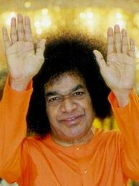  AUM  Mangalam Guru Devaaya,  Mangalam Gyan Dayine,  Mangalam Parthi Vasaaya,  Mangalam Sathya Sai Ne. (X3)  Om Shanti Shanti Shanti.  Samastha Lokaa Sukhino Bhavantu (X3)  Meaning:  "May The Divine Guru Be Auspicious To Us. May The Bestower Of Wisdom Be Auspicious To Us. May The Lord, Who Manifested In Parthi, Be Auspicious To Us. May Bhagwan Sathya Sai Baba Be Auspicious To Us". May all the worlds be happy.

2. Aumkaram

Omkaaram Bindhu Samyuktam
Nityam Dhyaayanti Yoginah |
Kaamadam Mokshadam Chaiva
Omkaaraaya Namo Namah ||
Meaning:
Om, which is united with the Source,
On which the Yogis ever dwell,
Which grants desires and liberation,
I salute the Omkaram.

4. Ganesh Mantra

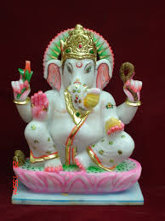

Vakra-Tunndda Maha-Kaaya
Suurya-Kotti Samaprabha
Nirvighnam Kuru Me Deva
Sarva-Kaaryessu Sarvadaa
Meaning:
1: O Lord Ganesha, of Curved Trunk, Large Body, and with the Brilliance of a Million Suns,
2: Please Make all my Works Free of Obstacles, Always

4. Gurur Brahma

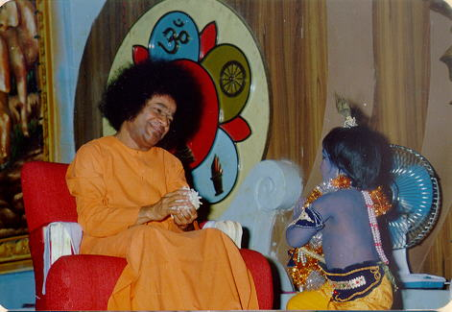

Gurur Brahma Gurur Vishnu
Gurur Devo Maheshwaraha
Gurur Saakshat Para Brahma
Tasmaï Sree Gurave Namaha

Meaning:
Guru is verily the representative of Brahma, Vishnu and Shiva. He creates, sustains knowledge and destroys the weeds of ignorance. I salute such a Guru.

5. MORNING PRAYER – LAKSHMI, SARASWATI AND GAURI

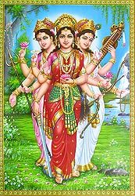

Karaagre Vaasate Lakshmi
Kara Madhye Saraswati
Kara Moole Tu Govinda
Prabahate Kara Darshanam

Meaning:
In the front part of the palm resides Lakshmi, in the middle (of the palm) Saraswati (resides), and at the root of the palm (manibandha) Gauri resides. Therefore start the day by looking at your hand (and remembering these gods, and reminding yourself that you should do good deeds with this hand today)

6. Vishnu Strotra

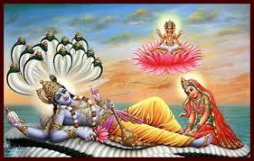

Shaanta-Aakaaram Bhujaga-Shayanam Padma-Naabham Sureshsham
Vishwa-adhaaram Gagana-Sadrusham Megha-Varnnam Shubhaanggam|
Lakshmi-Kaantam Kamala-Nayanam Yogibhir-Dhyaana-Gamyam
Vande Vishnum Bhava-Bhaya-Haram Sarva-Loka-Eka-Naatham ||
Meaning:
1: (Salutations to Sri Vishnu) Who has a Serene Appearance, Who Rests on a Serpent (Adisesha), Who has a Lotus on His Navel and Who is the Lord of the Devas,
2: Who Sustains the Universe, Who is Boundless and Infinite like the Sky, Whose Colour is like the Cloud (Bluish) and Who has a Beautiful and Auspicious Body,
3: Who is the Husband of Devi Lakshmi, Whose Eyes are like Lotus and Who is Attainable to the Yogis by Meditation,
4: Salutations to That Vishnu Who Removes the Fear of Worldly Existence and Who is the Lord of All the Lokas.

7. Saraswati Stotra

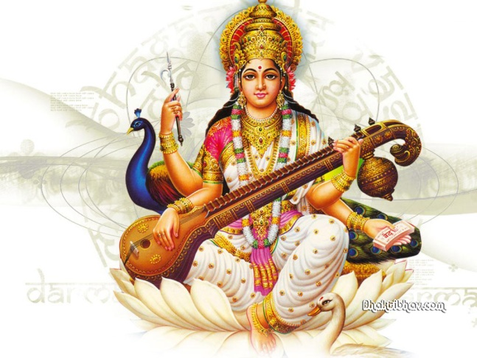
Yaa Kundendu Tussaara Haara Dhavalaa
Yaa Shubhra Vastraavrtaa
Yaa Veennaa Vara Danndda Mannddita Karaa
Yaa Shveta Padma asanaa |
Yaa Brahma Acyuta Shankara Prabhrtibhir
Devah Sadaa Vanditaa
Saa Maam Paatu Saraswati Bhagavatii
Nihshessa-Jaaddya-Apahaa ||1||

Meaning:
Salutations to Devi Saraswati, who is Pure White like Jasmine, with the Coolness of Moon, Brightness of Snow and Shine like the Garland of Pearls; and Who is Covered with Pure White Garments; Whose Hands are Adorned with Veena (a stringed musical instrument) and the Boon-Giving Staff; And Who is Seated on Pure White Lotus; Who is Always Adored by Lord Brahma, Lord Acyuta (Lord Vishnu), Lord Shankara and Other Devas; O Goddess Saraswati, Please Protect me and Remove my Ignorance completely.

8. Devi Mantra

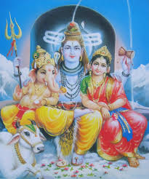

Om Sarva Mangala Mangalye
Shive Sarvatha Sadhike
Sharanye Tryambake Gauri
Narayani Namo-stute

Meaning:
Oh Gauri Maa! Consort of Lord Shiva,
You who bestows auspiciousness in all,
And fulfill everyone's wishes,
I prostrate myself before Thee,
Take me under your care

9. Shanti Mantra – I

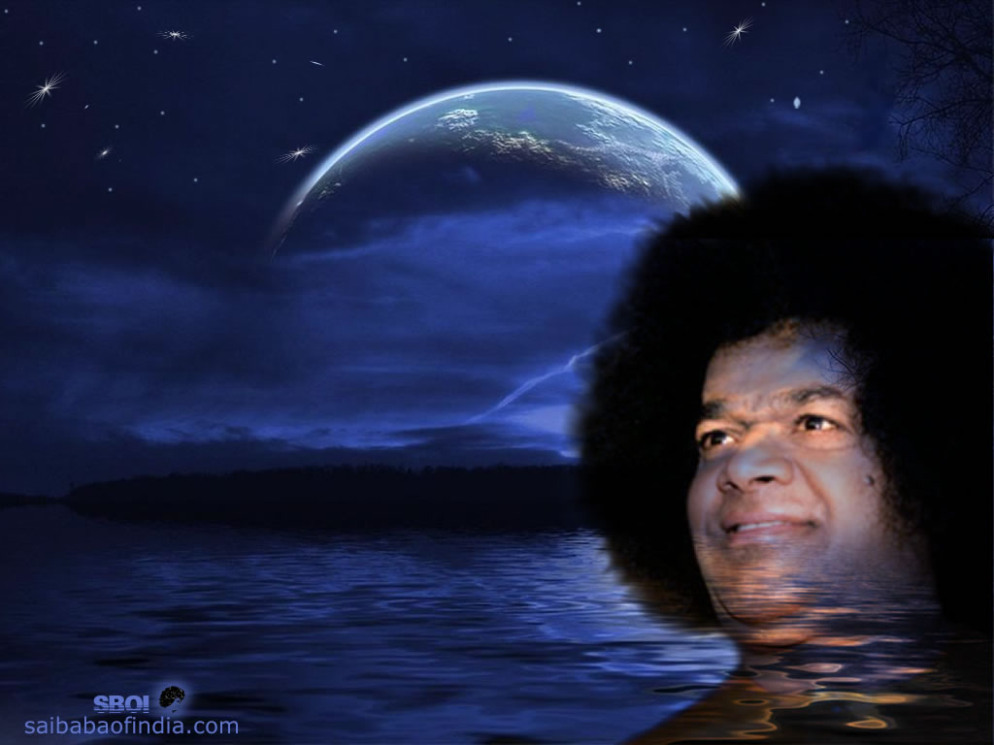

Om Sarve Bhavantu Sukhinah
Sarve Santu Nir-Aamayaah |
Sarve Bhadraanni Pashyantu
Maa Kashcit-Duhkha-Bhaag-Bhavet |
Om Shaanti Shaanti Shaanti ||

Meaning:
1: Om, May All become Happy,
2: May All be Free from Illness.
3: May All See what is Auspicious,
4: May no one Suffer.
5: Om Peace, Peace, Peace.

10. Shanti Mantra – II

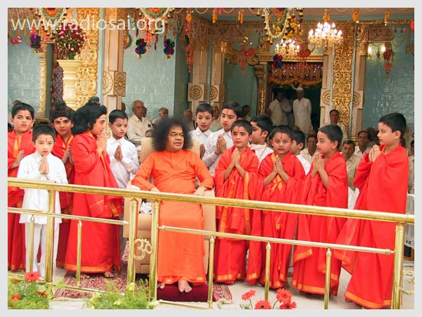

Om Sahana Vavaatu |
Saha Nau Bhunaktu |
Saha Viiryam Karavaavahai |
Tejasvi Naavadhiitam-Astu Maa Vidvissaavahai |
Om Shaanti Shaanti Shaanti ||

Meaning:
1: Om, May God Protect us Both (the Teacher and the Student),
2: May God Nourish us Both,
3: May we Work Together with Energy and Vigour,
4: May our Study be Enlightening and not give rise to Hostility,
5: Om, Peace, Peace, Peace.
11. Shanti Mantra – III

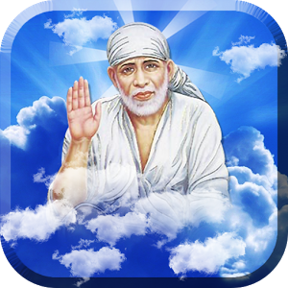

Om poornamadah poornamidam
poornaat poornamudachyate
(Om poornam-adah poornam-idah poorna-aat poornam udachyate)
Poornasya poornamaadaaya poornamevaavashishṣyate
(Om poorna-asya poornam-aadaaya poornam-evaa vashishyate)
Om shaanti shaanti shaanti

Meaning:
The Personality of Godhead is perfect and complete, and because He is completely perfect, all emanations from Him, such as this phenomenal world, are perfectly equipped as complete wholes. Whatever is produced of the complete whole is also complete in itself. Because He is the complete whole, even though so many complete units emanate from Him, He remains the complete balance.:
This is the Shanti mantra (invocatory verse) of Isha Upanishad (IshaVasya Upanishad) Which is a part of the (Shukla) Yajurveda.Om Peace, Phttps://in.answers.yahoo.com/question/index?qid=20090220070837AA5KShrhttps://in.answers.yahoo =20090220070837AA
12. Shanti Mantra IV

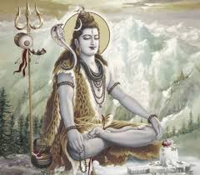

Om asato maa satgamaya
Tamaso maa jyotir gamaya
Mrityor maa amritam gamaya
Meaning:
Lead us from the unreal to the Real
From darkness to Light
From death to Immortality
Brihadaranyaka Upanishads (1.3.28).

13. Sloka on God: Tvameva Mata Ca Pita…

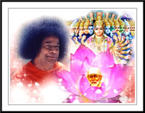

Tvam-Eva Maataa Cha Pitaa Tvam-Eva |
Tvam-Eva Bandhush-Ca Sakhaa Tvam-Eva |
Tvam-Eva Viidyaa Dravinnam Tvam-Eva |
Tvam-Eva Sarvam Mama Deva Deva ||

Meaning:
1: You Truly are my Mother And You Truly are my Father .
2: You Truly are my Relative And You Truly are my Friend.
3: You Truly are my Knowledge and You Truly are my Wealth.
4: You Truly are my All, My God of Gods.

14. Night Prayers for forgiveness

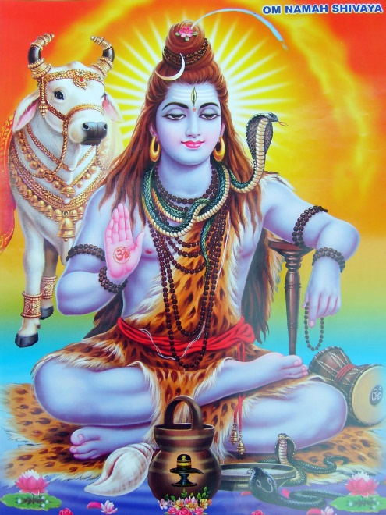

Kara Charana Kritham Vaak Kaayajam Karmajam Vaa
Sravana Nayanajam Vaa Maanasam Vaa Aparadham
Vihitham Avihitham Vaa Sarvametat Kshamasva
Jaya Jaya Karunaabdhe Sri Maha Deva Shambho
Meaning:
1: Whatever sins have been committed by actions performed by my hands and feet, produced by my speech and body, or my works,
2: Produced by my ears and eyes, or sins committed by my mind (i.e. Thoughts),
3: While performing actions which are prescribed (i.e. duties prescribed by tradition or allotted duties in one's station of life), as well as all other actions which are not explicitly prescribed (i.e. actions done by self-judgement, by mere habit, without much thinking, unknowingly etc); Please forgive them all,
4: Victory, Victory to You, O Sri Mahadeva Shambho, O Sri Sainath, I Surrender to You, You are an Ocean of Compassion.

15. Aum Ganaanaam Twa

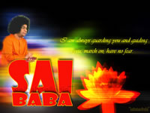
I am always with you...

Gananam tva Ganapati gum Havamahe
Kavim Kavinam Upamasra vastamam
Jyestharajam Brahmanam Brahmanaspat aana
Srnvan nuti bhissi dasadanam
Prano Devi Saraswati vajebhir vajeni vati
Dhinama vitraya vatu
Ganeshaya Namaha
Saraswatai Namaha
Shri Gurubhyo Namaha - Hari Hi Om

Meaning:
May we worship Ganapati, the Protector of Noble People. The best Poet, the Most Honourable, the greatest ruler and the treasure of all knowledge. O Ganapati, please listen to us and take your seat in our heart. May we worship Goddess of all learning and bestower of all knowledge to Her we prostrate. We bow to lord Ganesha, Devi Sarasvati and our divine Guru who removes darkness and ignorance. (Rig Veda 2.23.1)
16. The Lord’s Prayer
Our Father in heaven,
hallowed be your name.
Your Kingdom come,
your will be done,
on earth as in heaven
Give us today our daily bread.
Forgive us our sins,
as we forgive those who sin against us.
Lead us not into temptation,
but deliver us from evil.
For the kingdom, the power and the glory are yours.
Now and for ever. Amen

17. Lord Buddha’s prayer
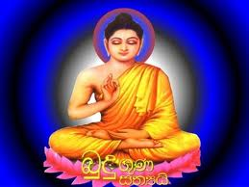

Buddham saranam gacchami
I go to the Buddha for refuge.
Dhammam saranam gacchami
I go to the Dhamma for refuge.
Sangham saranam gacchami
I go to the Sangha for refuge.

18. Gayatri Mantras

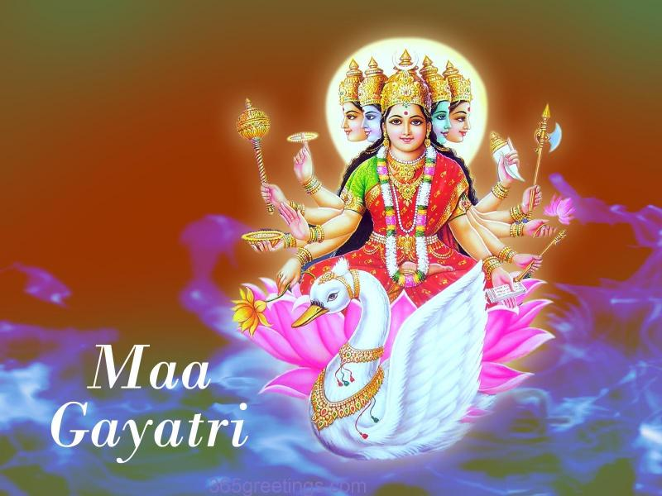

Om Bhuur-Bhuvah Svah
Tat-Savitur-Varennyam |
Bhargo Devasya Dhiimahi
Dhiyo Yo Nah Pracodayaat ||

Meaning:
We contemplate the glory of Light illuminating the three worlds: gross, subtle, and causal.
I am that vivifying power, love, radiant illumination, and divine grace of universal intelligence.
We pray for the divine light to illumine our minds.

Meaning of the individual words

Om: The primeval sound  Bhur: the physical world  Om: The primeval sound  Bhur: the physical world  Bhuvah: the mental world  Suvah: the celestial, spiritual world  Thath: That; God; transcendental Paramatma  Savithur: the Sun, Creator, Preserver | Varenyam: most adorable, enchanting  Bhargo: luster, effulgence  Devasya: resplendent,supreme Lord  Dheemahi: we meditate upon  Dhiyo: the intellect,understanding  Yo: May this light  Nah: our  Prachodayath: enlighten,guide,inspire

Sai (Eeshvara) Gaayathree  Subba Rao chanting it | Om.  Saayeeshvaraaya vidhmahe  Sathya-dhevaaya dheemahi  Thannah-Sarvah prachodayaath | Om.  We know this Sai as supreme divinity incarnate.  We meditate on this God of Truth.  May this Almighty All-in-all Personality lead us on  the path of total liberation.
Sai Suurya Gaayathree  Subba Rao chanting it | Om.  Shree Bhaaskaraaya vidhmahe  Saayi-dheyvaaya dheemahi  Thannah-Suurya prachodayaath | Om.  We know this Self-shining Entity.  We meditate on this divinity as Sai Suurya.  May this divine Light enlighten us on the path  of liberation.
Sai Hiranyagarbha Gaayathree  Subba Rao chanting it | Om.  Premaathmanaaya vidhmahe  Hiranyagarbhaaya dheemahi  Thannah-Sathyah prachodayaath | Om.  We know this embodiment of divine Love, Sathya Sai.  We meditate on this Golden-wombed divine personality.  May the Truth Incarnate, Shree Sathya Sai, inspire  us on the path of liberation  http://www.sathyasai.org/devotion/saithree/saithree.htm

19. Morning and evening prayer
The morning and evening prayers were given by Sathya Sai Baba in his discourse on 27 July 1961. He said,
" Adopt these as your daily prayers. The best thing is to have your own Self as the source of Light, as the guru. The Inner Intelligence, the Inner Guru will reveal the Truth. This prayerful attitude will so educate your impulses that the Inner Intelligence will be fully revealed
Morning prayer
Know that waking from sleep is but birth and going into sleep is death. On waking, pray every morning of your life,
“Oh Lord, I am born now from the womb of sleep.
I am determined to carry out all tasks this day as offerings to Thee, with Thee ever present before my mind’s eye.
Make my words, thoughts, and deeds sacred and pure.
Let me not inflict pain on anyone; let no one inflict pain on me.
Direct me, guide me, this day.”
Evening prayer
And when you enter the portals of sleep at night, pray,
“Oh Lord! the tasks of this day,
whose burden I placed on you this morning, are over.
It was You who made me walk and talk and think and act.
I therefore place at Thy Feet all my words, thoughts, and deeds.
My task is done.
Receive me, I am coming back to you.”

20. Prayer before meals

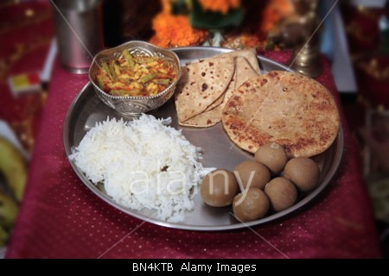

Brahmarpanam Brahma Havir Phonetic spelling: brahmaarpaNam brahma havir
Brahmagnau Brahmanaahutam brahmaagnaou brahmaNa aahutam
Brahmaiva Tena Ghantavyam brahmaiva tEna gantavyam
Brahmakarma Samadhina brahma karma samaadhinaa
Meaning: The act of offering is God, the oblation is God
By God it is offered into the Fire of God
God is That which is to be attained by him who performs action pertaining to God
Aham Vaishvanaro Bhutva Phonetic spelling: aham vaisvaanarO bhootvaa
Praninaam Dehamaashritaha praaNinaam dEhamaaSritaH
Pranapana Samayuktah praaNaapaana samaayuktaha
Pachaamyannam Chaturvidham pachaamyannam chaturvidham
Meanng: Becoming the life-fire in the bodies of living beings
mingling with the subtle breaths,
I digest the four kinds of food.

21. Sarva Dharma Prayer - Om Tat Sat

Om Tat Sat Sri Narayana Tu
Purushottama Guru Tu
Siddha Buddha Tu Skanda Vinayaka
Savita Pavaka Tu
Brahma Mazda Tu Yahve Shakti Tu
Ishu Pita Prabhu Tu
Rudra Vishnu Tu Rama Krishna Tu
Rahima Tao Tu
Vasudeva Go-Vishvarupa Tu
Chidananda Hari Tu
Advitiya Tu Akala Nirbhaya
Atmalinga Shiva Tu
Om, Thou art that, Thou art Narayana,
God in the form of man;
Thou art the Embodiment of perfection and the perfect master.
Thou art enlightened Buddha;
Thou art Subramanya and Ganesha, the remover of obstacles;
Thou art the Sun-fire;
Thou art Brahma, the Creator;
Mazda, the Great One;
Thou art Jehovah and the Divine Mother, the creative Energy.
O Lord! Thou art the Father of Jesus.
Thou art Rudra, the Transformer, and Vishnu, the Preserver;
Thou art Rama and Krishna;
Thou art Rahim, all kindness, always giving and expanding;
Thou art the Tao.
Thou art Vasudeva, the Sustenance of all, omnipotent and omnipresent;
Thou art Hari, Destroyer of illusion, the blissful Spirit.
Thou art unparallelled, beyond time and fearless of adversities;
Thou art Shiva, Creator of the lingam, Symbol of the formless Absolute.
.

22. Aarthi in the praise of Swami

Om Jai Jagadisha Hare Swami Sathya Sai Hare
Bhakta Jana Samrakshaka (2 ×)
Parthi Maheshvara Om Jai Jagadisha Hare

Shashi Vadana Shrikara
Sarva Prana Pate Swami Sarva Prana Pate
Ashrita Kalpalatika (2 ×)
Apad Bandhava Om Jai Jagadisha Hare

Mata Pita Guru Devamu
Mari Antayu Nive Swami Mari Antayu Nive
Nadabrahma Jagannatha (2 ×)
Nagendrashayana Om Jai Jagadisha Hare

Omkararupa Ojasvi
Om Sai Mahadeva Sathya Sai Mahadeva
Mangala Arati Anduko (2 ×)
Mandaragiridhari Om Jai Jagadisha Hare

Narayana Narayana Om
Sathya Narayana Narayana Narayana Om
Narayana Narayana Om
Sathya Narayana Narayana Om
Sathya Narayana Narayana Om
Om Jai Sadguru Deva
Om Shanti shanti shanti
Jai Bolo Bhagavan Sri Sathya Sai Baba-Ki – JAI

Meaning:
Victory to the Lord of the universe, Lord Sathya Sai,
Who destroys grief, evil and miseries of life and
Who guards and protects devotees.
Victory to the Lord of the universe,
Lord of Lords - Lord of Parthi.

O graceful and charming as a full moon!
O Auspicious One! O Lord Sai! Thou art the indweller
and life-force of all beings;
the wish-fulfilling Divine creeper to those
who have surrendered to Thee;
and kinsman, protector and friend in
times of distress and calamities.
Victory to the Lord of the universe.
O Lord Sai! Thou art Mother, Father, Noble Teacher,
Supreme Divinity and everything to us.
O Lord of the universe!
Thou art primeval sound and reclines on the coiled serpent.
Victory to the Lord of the universe.

Chant the name of Lord Sathya Sai Narayana,
Whose Form is Pranava.
Victory to the noble teacher and supreme Lord Sathya Sai.

23. Vibhuthi Mantra

Paramam Pavitram Baba Vibhutim
Paramam Vichitram Lila Vibhutim
Paramartha Ishtartha Moksha Pradanam
Baba Vibhutim Idamashrayami

Meaning: I take refuge in the supremely sacred Vibhuti of Lord Baba,
the wonderful Vibhuti, which bestows salvation,
the sacred state which I desire to attain.

English Version
Sacred Holy and Supreme is Baba's Vibhuthi
Pouring Forth in brilliant stream, this play of Vibhuthi
So auspicious is its might, it grants liberation
Baba's Vibhuthi, its power protects me.

When we recite this mantra, we say “I take refuge in the supremely sacred vibhuti of the Lord, the wonderfulvibhuti which bestows liberation, the sacred state which I desire to attain.”Since this mantra is so powerful, we should recite it with respect and with sincerity in order that we gain the full benefit from it.
24. Five Human Values:
Truth, Right Conduct, Peace, Non-Violence and Love
What are Human Values?
The five basic human values of Truth, Right Conduct, Peace, Non-Violence and Love are essential, like the fingers of the hand. Each helps towards the proper functioning and efficiency of the whole hand. The following are examples of commonly recognised character attributes of the five universal human values.

25. Nine points of conduct
The charter of the Sai Organization says that every member should undertake sadhana (spiritual discipline) as an integral part of daily life and abide by the following Code of Conduct :
- Daily meditation and prayer.
- Devotional singing/prayer with family members once per week.
- Participation in Sai Spiritual Education by children of the family..
- Participation in community service and other programmes of the Organisation.
- Regular attendance at devotional meetings conducted by the Organisation.
- Regular study of Sathya Sai Baba literature.
- Use of soft, loving speech with everyone.
- Avoidance of talking ill of others, especially in their absence.
- Practice of the principles of “ceiling on desires”, consciously and continuously striving to eliminate the tendency to waste time, money, food, and energy and utilising any savings thereby generated for the service of mankind.

26. Ten-fold path to Divinity
In His discourse at the World Conference on 21 November 1985, Sathya Sai Baba gave ten principles that should guide our lives.
1. Love and serve your country. Do not be critical of others' countries.
2. Honor and respect all religions as pathways to God.
3. Love all humanity as part of your family; know that humanity is a single community.
4. Keep home and surroundings clean.
5. Help the needy with food, clothing, and shelter. Help them become self-reliant
when possible.
6. Be examples of honesty. Do not participate in any corruption such as bribery.
7. Curb jealousy, hatred, and envy.
8. Develop self-reliance; become your own servant before proceeding to serve others.
9. Adore God, abhor sin.
10. Observe your country's laws and be an exemplary citizen.

